Level 1 - Functional Business Requirement

System | IBM SND | Date | 20 Oct 2008
Title | Transportation module | Project Name | IBMSND
FBR No. | IBMSND Transportation | Client Ref. Name | IBMSND
Status |  | Author | Pei Fong
Business Approval
Approval Date

Table Content

1. Version History 2
2. Description 2
3. Scope 2
4. Assumptions 2
5. Detail Specs 3
5.1. Transportation Setup 3
5.1.1 Vehicle Setup 3
5.1.2 Requestor Setup 3
5.1.3 Delivery Address Setup 4
5.1.4 Bill Code setup 4
5.2. Transportation Maintenance 5
5.3. Daily Delivery Manifest 5
5.4. Transportation – Update Amount 6
5.4.1 Generate Billing Amount 6
5.4.2 Transportation – Update Amount 7
5.5. Transportation Billing Report 9
5.6. Upload Transport Job 10

Version History

Version | Description | Date | By
1.0.0 | Initial Draft | 2008/10/20 | Pei Fong
1.1.0 | Add charge amount.  Transportation billing update screen | 2008/11/13 | Pei Fong

Description

This functional specification describes detail IT spec of new Transportation Entry module.

This module includes:
1. Maintain information of daily delivery data, Pick-up and delivery addresses, delivery date time, no of packages, packages dimension and other customer information.

2. Allow user to print out Daily delivery manifest by vehicle and day.

3. At the end of the week/month, Transportation billing report will be generated.

Scope
- Develop Transportation maintenance.
- Daily Delivery manifest by vehicle by day
- Transportation billing report by range of job date
- Billing amount update

Assumptions

Detail Specs
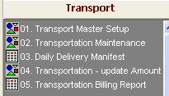

Transportation Setup

Vehicle Setup
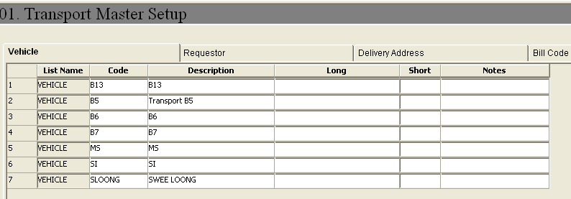

Requestor Setup
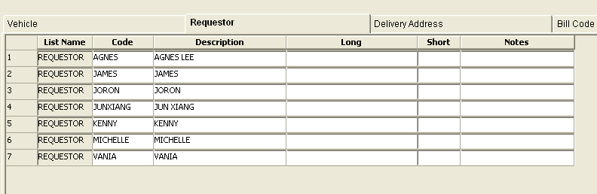

Delivery Address Setup
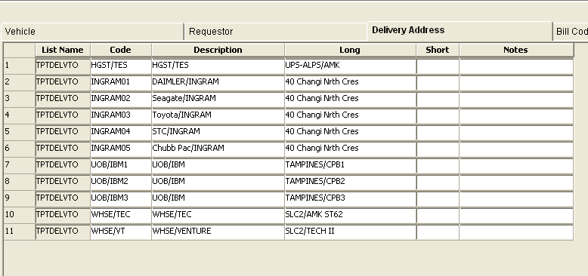

Bill Code setup
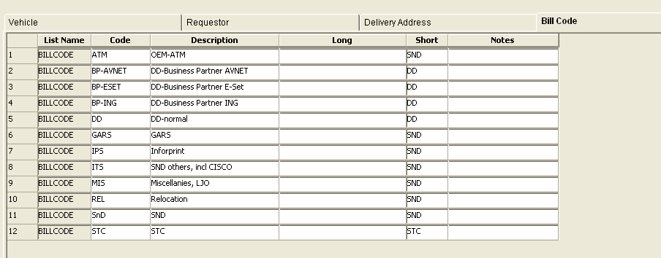

Transportation Maintenance

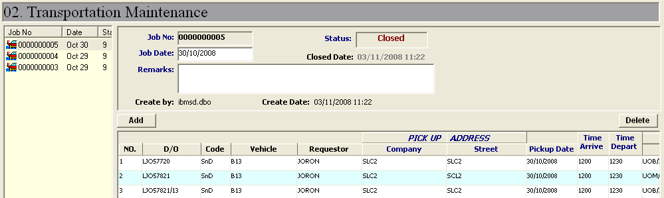
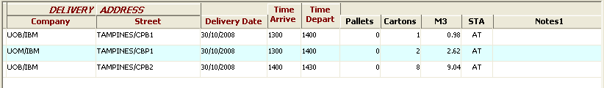

Data Validation:
  - No duplication of DO No.
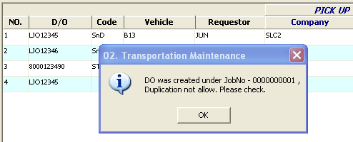

Daily Delivery Manifest
Retrieve by Job Date and Vehicle Code

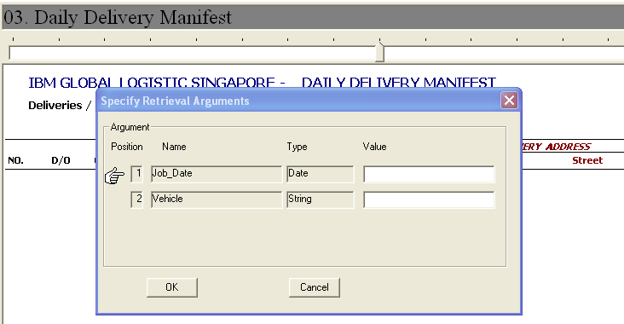

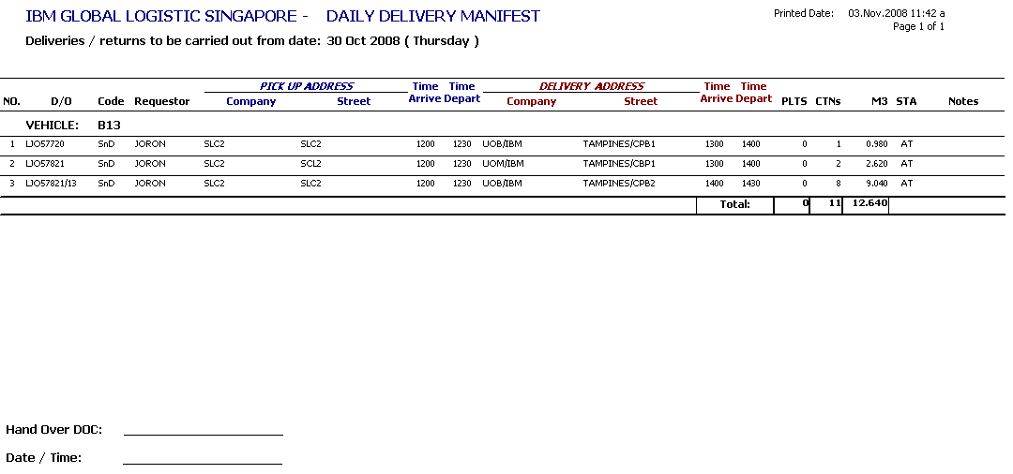

Transportation – Update Amount
Description: Screen allow supervisor to update billing amount

Generate Billing Amount
- Go to ->Transportation Maintenance, select respective Job
- Click button
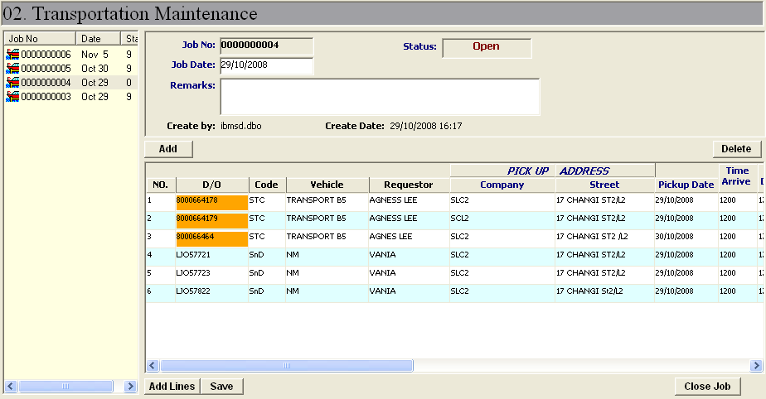
DO will be highlighted if the M3 or carton information is missing

- Job not allow to close, if exists missing information. 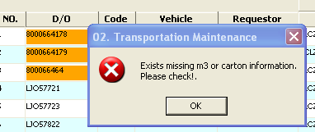

- Charge amount will be generated after job is closed.

Transportation – Update Amount

Admin or supervisor can update charge amount by job no.

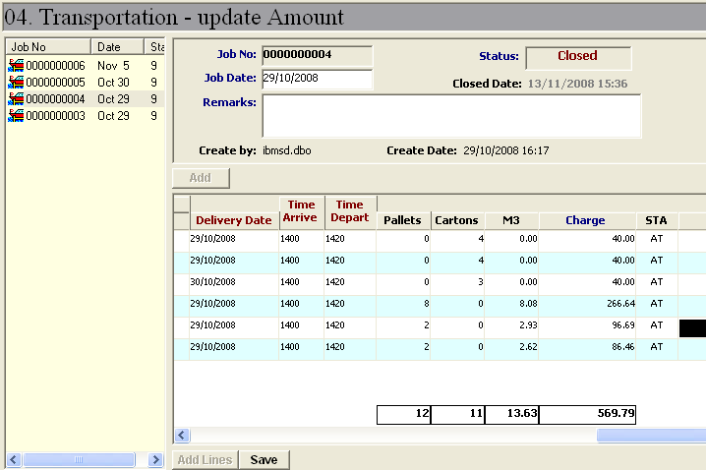

Transportation Billing Report

[HUB] :: [6.Billing] -> Transportation Billing

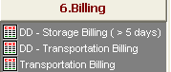

Retrieve by Bill Code, Job Date range

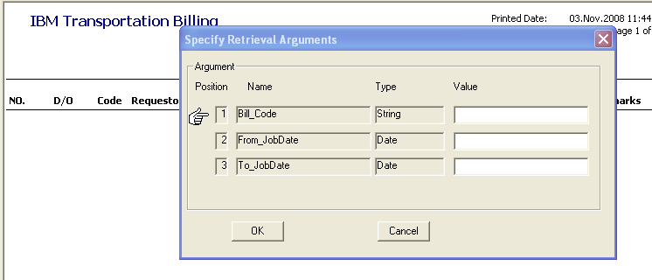

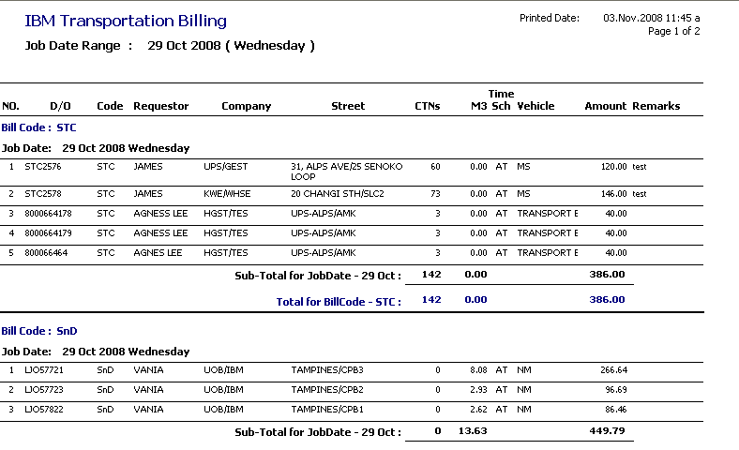

Upload Transport Job

Step:
- Prepare transport job data in excel, see sample template.
- Save file as Text Delimited (.txt), without header.
- Launch HUB-> Transport -> 00. Upload Transport Job
- Click [Import] button, browse for prepared text file.
- Click [Save] button, to save transport job into system.

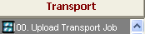

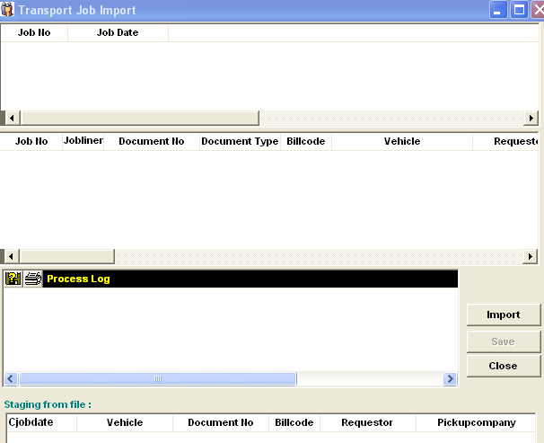

Transport Upload Template
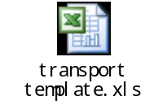

=== End of Document ===

